Epsom & Ewell F.C.
16
v
Redhill F.C.
Saturday, 2nd January 2016 – 3.00pm
Good afternoon and Happy New Year! We welcome the players, supporters and officials of Redhill Football Club, together with today’s match officials and our own regular supporters.

Matches against Redhill have been few and far between in recent years, but we have many earlier meetings, some of which were very big matches in front of enormous crowds. It is now difficult to picture, let alone remember the many thousands who used to attend meetings between these sides back in those halcyon pre and post-war days. I cover those encounters in more detail later in the programme.

Today’s opponents have had a very poor start to life in the Combined Counties League, following their relegation from the Ryman League South. Although matters have improved, a tough second half of the season awaits them as they attempt to climb out of the bottom three. Many clubs have failed to do so in recent years, only to win a reprieve at the end of the season, but the only way to really control your own destiny is to finish above that line, and whilst we wish them well in their attempts, I’m sure they will understand that we need the points quite urgently ourselves!

We were last here before Christmas when Sutton Common Rovers visited us, and a spectacular three goal burst early in the second half did the damage. A 90th minute consolation was the least they deserved as they matched us for large periods of the game, but the goals we are scoring these days are almost all worthy of a highlight reel! Reisse Griffin opened the scoring with a scintillating volley before Rob Hendry clinically took advantage of a defender error and then Tom Neale smashed one into the top corner from 30 yards.

After that we travelled to Horley Town on the Bank Holiday Monday morning, where we had our usual contentious and feisty match! This time it was the opposition that had a man sent off and we turned a 1-0 deficit into a 2-1 lead before being pulled back by a late penalty and drawing 2-2. We may well have to wait until the end of the season before we find out whether those dropped points will cost us, but I thought a draw was a fair result over the ninety minutes.

We have no midweek match before making our first visit to Farm Park since February 2006 for our return League match with AFC Hayes on Saturday. Then three days after that match we return here for our last 16 League Cup tie against Ashford Town (Mx).

All of these are challenging matches as we continue to chase Hartley Wintney at the top of the table, so please come along and support your team.

Enjoy the game!

Rich

You can now follow us on Facebook www.facebook.com/epsomandewellfc or Twitter @EEFCOfficial

Cover Photos – 1) by Gemma Jarman – 2) by Epsom & Ewell Advertiser

- Our boys celebrate Kyle Hough’s winning goal at Redhill back in August
- Alex Reid scores in our 1-0 win over Redhill at West Street in January 1977

Cherry Red Records Combined Counties League
Premier Division Table 2015/16
inc Monday 28th December | P | W | D | L | F | A | Pts | GD | H | A
Hartley Wintney | 21 | 17 | 2 | 2 | 66 | 21 | 53 | +45 | 30/1 | 3-3
Ashford Town (Mx) | 22 | 17 | 1 | 4 | 55 | 26 | 52 | +29 | 30/4 | 3-2
Epsom & Ewell | 22 | 14 | 6 | 2 | 54 | 20 | 49 | +34 | X | X
Camberley Town | 19 | 13 | 3 | 3 | 37 | 17 | 42 | +20 | 16/4 | 20/2
Hanworth Villa | 22 | 12 | 2 | 8 | 41 | 34 | 38 | +7 | 5-0 | 23/4
Horley Town | 20 | 11 | 4 | 5 | 50 | 29 | 37 | +21 | 27/2 | 2-2
Colliers Wood United | 25 | 11 | 2 | 12 | 52 | 43 | 35 | +9 | 3-1 | 3-0
Windsor | 22 | 8 | 8 | 6 | 41 | 41 | 32 | 0 | 2-2 | 23/1
Spelthorne Sports | 22 | 9 | 5 | 8 | 40 | 43 | 32 | -3 | 16/1 | 6-2
Raynes Park Vale | 23 | 9 | 2 | 12 | 46 | 49 | 29 | -3 | 3-1 | 28/3
AFC Hayes | 23 | 8 | 4 | 11 | 35 | 42 | 28 | -7 | 1-1 | 9/1
Sutton Common Rovers | 23 | 8 | 3 | 12 | 42 | 46 | 27 | -4 | 3-1 | 2-1
Guildford City | 23 | 8 | 3 | 12 | 46 | 57 | 27 | -11 | 4-0 | 2/4
Knaphill | 18 | 8 | 2 | 8 | 32 | 26 | 26 | +6 | 12/3 | 1-1
Farnham Town | 21 | 7 | 4 | 10 | 35 | 35 | 25 | 0 | 1-0 | 6/2
Westfield | 17 | 6 | 6 | 5 | 23 | 26 | 24 | -3 | 26/3 | 0-0
Chessington & Hook | 22 | 7 | 2 | 13 | 40 | 52 | 23 | -12 | 1-0 | 19/3
Bedfont Sports | 21 | 5 | 7 | 9 | 29 | 32 | 22 | -3 | 13/2 | 2-2
Badshot Lea | 21 | 7 | 1 | 13 | 26 | 53 | 22 | -27 | 9/4 | 1-0
Chertsey Town | 22 | 5 | 5 | 12 | 22 | 36 | 20 | -14 | 0-1 | 5/3
Redhill | 18 | 3 | 3 | 12 | 23 | 43 | 12 | -20 | 2/1 | 1-0
Cove | 17 | 1 | 0 | 16 | 9 | 73 | 3 | -64 | ??? | 7-0

Lucky Day? – 2nd January
Played 12 - W 5 D 4 L 2 AB 1 - F 28 A 17 - PPG 1.73 - Very Good
Our Club record against Redhill
Played 32 - W 13 D 2 L 17 - F 60 A 69 - PPG 1.28 - Below Average
Largest wins and losses against Redhill
10th March 1928 - (H) W 7-2 - Cup - 12th December 1925 - (H) L 2-8 - Cup
Their Last visit
Tuesday 20th January 2009 - W 3-0 - Surrey Senior Cup

Club Manager - Glyn Mandeville
Good afternoon everyone and welcome to today’s game against Redhill. I do hope everyone had a great Christmas and New Year.

We come into this game after a very good year, only losing once in the league and remaining unbeaten away from home. The lads have worked so hard so far this season and we hope to carry on in the new year.

We are still missing players through injury and hope to get them back fit soon.
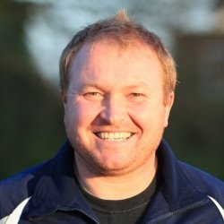
I hope you enjoy today's game and have a safe trip home.

Cheers for all your support.

Manders

Club Captain - Sam Currie
Good afternoon and welcome to today's game against another local side in Redhill.

After last Monday's game against Horley which we knew would be a tough one and it didn't let us down - particularly with the pitch condition - we were a little disappointed to come away with only the one point, having led in the game late on, only to see a harsh penalty awarded which meant that we were unable to do this.

This means we will be looking to hopefully put things right today and provide a performance that is worthy to get back on the winning track.

We know things won't be easy today and will again have to be at our best as Redhill are still a big club and will be wanting to start a run up the table at some point, probably sooner rather than later.

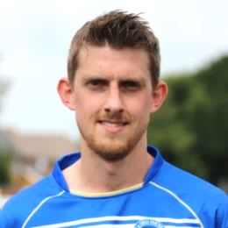
Therefore, we hope you’re in for a good game today and on behalf of the squad, I wish you all a happy New Year and a safe journey home following today's match.

Sam

Latest Results and Fixtures
Combined Counties League – Saturday 19th December
AFC Hayes | 0-5 | Ashford Town (Mx)
Badshot Lea | 1-3 | Farnham Town
Bedfont Sports | 2-1 | Camberley Town
Colliers Wood United | 5-2 | Knaphill
Epsom & Ewell | 3-1 | Sutton Common Rovers
Guildford City | 4-2 | Chertsey Town
Hartley Wintney | 2-0 | Hanworth Villa
Raynes Park Vale | 2-3 | Horley Town
Windsor | 1-1 | Spelthorne Sports
Combined Counties League – Tuesday 22nd December
Sutton Common Rovers | 3-0 | Redhill
Combined Counties League – Monday 28th December
Ashford Town (Mx) | 2-1 | Windsor
Camberley Town | 3-1 | Hartley Wintney
Chertsey Town | 0-1 | Colliers Wood United
Farnham Town | 2-2 | Guildford City
Hanworth Villa | 2-1 | Bedfont Sports
Horley Town | 2-2 | Epsom & Ewell
Raynes Park Vale | 3-2 | Chessington & Hook United
Spelthorne Sports | 3-2 | AFC Hayes
Combined Counties League – Tuesday 29th December
Knaphill | V | Westfield
Combined Counties League – Saturday 2nd January
Ashford Town (Mx) | V | Knaphill
Badshot Lea | V | Westfield
Bedfont Sports | V | Windsor
Camberley Town | V | Chessington & Hook United
Cove | V | Spelthorne Sports
Epsom & Ewell | V | Redhill
Hanworth Villa | V | Guildford City
Hartley Wintney | V | Farnham Town
Horley Town | V | Chertsey Town
Sutton Common Rovers | V | AFC Hayes
Combined Counties League – Tuesday 5th January
AFC Hayes | V | Westfield
Chessington & Hook United | V | Horley Town
Knaphill | V | Badshot Lea
Raynes Park Vale | V | Windsor
Redhill | V | Spelthorne Sports
Latest Results and Fixtures
Combined Counties League – Saturday 9th January
AFC Hayes | V | Epsom & Ewell
Bedfont Sports | V | Chertsey Town
Farnham Town | V | Camberley Town
Raynes Park Vale | V | Ashford Town (Mx)
Redhill | V | Cove
Spelthorne Sports | V | Badshot Lea
Westfield | V | Horley Town
Windsor | V | Colliers Wood United
Combined Counties League Cup – Tuesday 12th January
Camberley Town | V | Spelthorne Sports
Cobham | V | Frimley Green
Epsom & Ewell | V | Ashford Town (Mx)
Combined Counties League – Tuesday 12th January
Horley Town | V | Hartley Wintney

Player Profile – Number 11 – Reisse Griffin
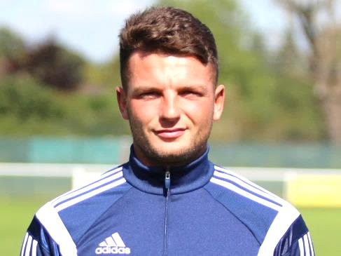
Our latest player profile is from another of our new players this season, Reisse Griffin.

Age: 25

Position: Winger

Club supported: Arsenal

Favourite Food: Curry

Favourite Film: Jump Street

Messi or Ronaldo: Ronaldo

Favourite Drink: Red Bull

Favourite Holiday Destination: Las Vegas

Favourite Ground played at: Stamford Bridge, Chelsea FC

Best Moment for Epsom & Ewell: My first goal!

Describe the Gaffa in three words: Funny – Good-looking – Tall

Reisse’s Playing Stats: First Team Debut : 08/08/2015

Appearances: 11 - Sub: 4 - Total: 15 - Goals: 1

First Eleven Appearances - (max 26 – including Horley Town – 28/12/15)
Name | Debut | 2014/15 |  |  |  | Career Totals
 |  | App | Sub | Total | Goals | App | Sub | Total | Goals
AJAYI Tayo | 22/08/2015 | 0 | 2 | 2 | 0 | 0 | 2 | 2 | 0
COOPER-SMITH Daryl | 03/01/2015 | 15 | 4 | 19 | 8 | 24 | 7 | 31 | 14
CURRIE Sam | 04/08/2012 | 16 | 1 | 17 | 1 | 124 | 10 | 134 | 3
DAVISON Conor* | 22/08/2015 | 1 | 2 | 3 | 0 | 1 | 2 | 3 | 0
DEAN Dan | 02/08/2014 | 17 | 2 | 19 | 0 | 53 | 3 | 56 | 0
DOWNS Carl | 17/09/2011 | 4 | 1 | 5 | 0 | 98 | 14 | 112 | 2
EACOTT Michael | 02/08/2014 | 23 | 0 | 23 | 0 | 69 | 0 | 69 | 0
FARRELL Matt | 02/08/2014 | 25 | 0 | 25 | 5 | 66 | 3 | 69 | 12
FERDINANDO Matt | 20/09/2014 | 17 | 0 | 17 | 5 | 44 | 4 | 48 | 11
GRIFFIN Reisse | 08/08/2015 | 11 | 4 | 15 | 1 | 11 | 4 | 15 | 1
HASTINGS Craig | 08/08/2015 | 19 | 3 | 22 | 0 | 19 | 3 | 22 | 0
HENDRY Rob | 08/08/2015 | 22 | 3 | 25 | 9 | 22 | 3 | 25 | 9
HOUGH Kyle | 14/08/2007 | 20 | 2 | 22 | 17 | 316 | 17 | 333 | 188
JONES Adrian | 06/08/2011 | 2 | 0 | 2 | 0 | 22 | 0 | 22 | 0
KURDZIEL Jakub | 29/08/2015 | 1 | 0 | 1 | 0 | 1 | 0 | 1 | 0
MARVELL Dale* | 15/01/2000 | 8 | 4 | 12 | 1 | 269 | 49 | 318 | 86
MCGREGOR Alex | 08/08/2009 | 7 | 2 | 9 | 2 | 179 | 58 | 237 | 29
MCKAY Alex | 20/12/2008 | 17 | 1 | 18 | 0 | 102 | 27 | 129 | 8
NEALE Thomas | 13/10/2015 | 6 | 8 | 14 | 4 | 6 | 8 | 14 | 4
NEILL David* | 03/10/2015 | 1 | 1 | 2 | 0 | 1 | 1 | 2 | 0
NORTH Rhys | 16/08/2015 | 8 | 6 | 14 | 0 | 8 | 6 | 14 | 0
OLIVER Beckett | 29/08/2015 | 5 | 10 | 15 | 0 | 5 | 10 | 15 | 0
PANAYIOTOU Savvas | 03/01/2015 | 2 | 2 | 4 | 0 | 18 | 5 | 23 | 3
ROWE Steve | 27/08/2011 | 0 | 1 | 1 | 0 | 24 | 3 | 27 | 0
SMITH Matt | 08/08/2009 | 0 | 0 | 0 | 0 | 91 | 43 | 134 | 10
TANTON Matt | 02/08/2014 | 22 | 0 | 22 | 0 | 40 | 4 | 44 | 1
TAYLOR James | 26/08/2013 | 17 | 2 | 19 | 2 | 73 | 10 | 83 | 5
Own Goal |  |  |  |  |  |  |  |  | 1
* Player has left the club

EL Records Premier Challenge Cup
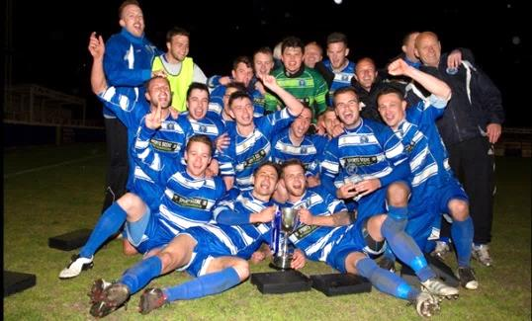
Second Round
Dorking Wanderers | 2-1 | South Park Reserves
Westfield | 1-0 | CB Hounslow United
Bedfont & Feltham | 1-5 | Colliers Wood United
Dorking | 0-3 | Knaphill
Badshot Lea | 2-4 | Spelthorne Sports
Hanworth Villa | 1-2+ | Chertsey Town
Ashford Town (Mx) | 2-1 | Epsom Athletic
Hartley Wintney | 4-2 | Horley Town
Banstead Athletic | 1-1+ | Epsom & Ewell
Epsom & Ewell won 7-6 on penalties
Sheerwater | 3-3+ | Frimley Green
Frimley Green won 8-7 on penalties
Farnham Town | 3-2 | Abbey Rangers
Camberley Town | 4-2 | Eversley & California
AFC Hayes | 0-1 | Banstead Athletic
Redhill | 3-0 | Sutton Common Rovers
Worcester Park | 1-5 | Chessington & Hook United
Cove | 1-6 | Cobham
Third Round
Camberley Town | 12/1 | Spelthorne Sports
Cobham | 12/1 | Frimley Green
Redhill | V | Farnham Town
Raynes Park Vale | V | Westfield
Epsom & Ewell | 12/1 | Ashford Town (Mx)
Colliers Wood United | 6-0 | Dorking Wanderers Reserves
Knaphill | V | Chertsey Town
Hartley Wintney | V | Chessington & Hook United

From behind the goal
Epsom & Ewell 3-1 Sutton Common Rovers
Combined Counties League - Premier Division - Saturday 19th December 2015

Rovers seen off by second half blitz

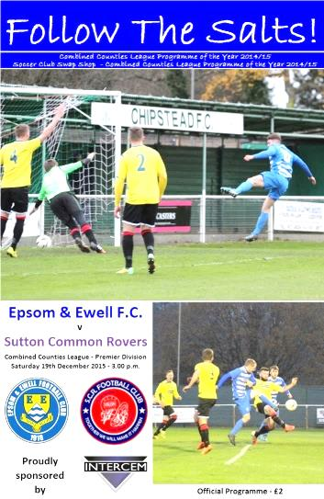
We negotiated a tricky hurdle on Saturday when they defeated Sutton Common Rovers by three goals to one. This was a tough looking fixture based on the visitors’ recent form and it took us until the second half before we were able to show our own quality, blowing the opponents away with three ferocious strikes to add to our already impressive number of spectacular goals this season.

We were no doubt going to be fielding an unchanged eleven from last Saturday's win, until Friday night's car accident involving Tom Neale and Matt Ferdinando. Our match winner from last week was battered and bruised and unable to take part in this match, although should be fine by the time our next game comes around, while Neale was in better shape and started on the bench but would come onto the field to great effect later. Matt Tanton and Rob Hendry came into the starting eleven instead so we were still very strong, although there was still no sign of the injured James Taylor or Sam Currie.

The first half was a bit of an anti-climax really. Losing the toss and going against the wind, there was every hope that we could turn around with a healthy lead as was the case against Guildford City two weeks previously, but there was no way this was going to happen against a committed and competitive Rovers team, buoyed by their F.A.Vase win just seven days previously. In fact the visitors shaded possession in the first half, although there were few in the way of real chances. It was a half of nearly and not quite, as first the visitors squared a dangerous ball across our goal but there was no one there to apply the finishing touch, while moments earlier an Alex McKay delivery was just too high for Matt Farrell, who would have only required the slightest header to defeat the exposed keeper Harvey Cheadle, brother of former Epsom players Jordan and Adam.

Tanton, playing in an advanced left midfield role on his return from suspension had a good opportunity but was unable to lift his shot over the keeper from the edge of the area. Less than a minute later it was our turn to breathe a sigh of relief as a speculative attempt from out on the Sutton left cleared our bar by inches with Michael Eacott unable to get there.

We had our best opportunity in the 32nd minute when Kyle Hough intercepted a clearing header and cut in from the left corner of the area, but whilst his shot was good enough to beat the keeper it was cleared off the line by Anson Collins. A couple of corners followed and Reisse Griffin saw his low effort palmed away for another set piece which Dan Dean was then almost able to make contact with. It was clear that we were the more dangerous side going forward but we hadn't done as much of it as the visitors who were making a real game

of it and required Eacott to come out quickly and make a good save just before the half.

Unfortunately during the first half McKay fell awkwardly and at the break he was replaced by Tom Neale with Tanton reverting to left back. Arguably this gave us a little more balance and it took just six minutes of the second period before we were ahead, but what a goal it was, starting with Hendry, who found Hough on the left hand side near the penalty area. He beat his man and burst into the box before laying the ball back into the path of Farrell, who produced a super left footed cross over everyone and almost beyond Griffin at the far post, but our man stretched and hit a scintillating volley into the roof of the net from 12 yards, giving Cheadle no chance. What a way to score your first competitive goal for the club!

Five minutes later we had extended our lead. A defensive error was pounced upon by Hendry and from the edge of the box, he curled a left footed shot just inside Cheadle's right hand post. Game over, it appeared. Of course it should be remembered that Sutton Common Rovers were 2-0 down the previous week before fighting back to win and they sparked into life. Eacott made a good save with his feet from Francois Gabbidon and it was clear that we just needed to weather the storm for five minutes, but no one told Neale who received the ball thirty yards out and promptly lashed the ball into the top corner to make it 3-0 to the Salts in the 59th minute.

Shortly after this Rhys North, having been injured earlier in the match, picked up another knock and was replaced by the returning Savvas 'Agi' Panayiotou with Griffin dropping to right back. Despite him playing further back now, he almost scored again after 69 minutes when a cross was picked up by the wind and missed the top corner by a matter of feet.

Unfortunately, Tanton picked up a booking for a shirt pull in the 73rd minute and then just two minutes later cleared the ball away just after the referee had awarded a free kick against us. It was a little after the whistle and probably deserving of a yellow card, although on many other occasions the player would have received the benefit of the doubt, but not this time, so our full back made the short walk back to the dressing room a little earlier than intended.

The visitors put on two substitutes, pushing forward in an attempt to reduce the deficit and the game was stretched for a while as a result. We had a great opportunity to extend our lead when Cheadle flapped at a high ball under pressure from Neale and the loose ball fell to Farrell but he shot wide, while at the other end, two attempts were blocked but not a third as Arnold Okiror scored from close range in the 90th minute to end our run of games without conceding at three, instead of the four it so nearly was.

This was a disappointing ending but ultimately it made no difference to the most important thing, the result, and I would be more than happy to concede a late goal every week if we were already 3-0 up by then! Overall though the opposition did deserve something out of this game and a three clear goal win would have been harsh on them. For us, we will have to produce our best form for the full ninety minutes when we visit Horley Town, another of the top five on the Monday Bank Holiday, or we may pay a heavy price.

Team: Michael Eacott, Rhys North, Alex McKay, Dan Dean, Craig Hastings, Carl Downs, Matt Tanton, Matt Farrell (c), Kyle Hough, Rob Hendry, Reisse Griffin

Subs: Tom Neale for McKay (45), Savvas 'Agi' Panayiotou for North (62)

From behind the goal
Horley Town 2-2 Epsom & Ewell
Combined Counties League - Premier Division - Monday 28th December 2015

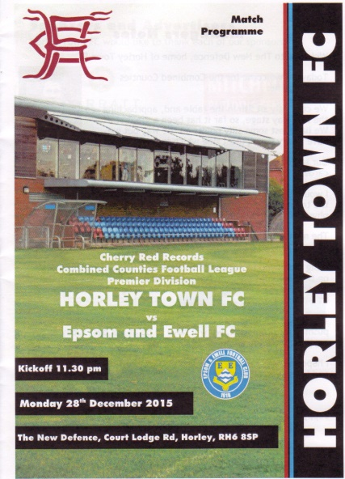
A chance missed - or a point gained?

Matches between Horley and ourselves are frequently incident packed and whilst the first half was fairly quiet by past standards, the second more than made up for it as both teams ended up with a point from their endeavours, but might feel they deserved more.

We only made one change to the starting eleven from the win over Sutton Common Rovers with Tom Neale coming in and Rhys North, absent on holiday, dropping out. This obviously led to quite a reshuffle of positions, the most notable of which was Alex McKay proving his versatility by moving from left back to play at right back! We were still missing Matt Ferdinando after his car accident, although long term absentees Sam Currie and James Taylor were back on the bench. Daryl Cooper-Smith remains suspended and we won't see him for a while yet.

Both teams had an early chance in the first half. Michael Eacott was called into action as early as the second minute when he had to divert a raking ball in from the right away from an incoming striker, while Matt Farrell had a free kick on the edge of the box, but missing any of our established free kick specialists, he clipped it weakly wide of George Hyde's goal two minutes later.

On a soft and boggy pitch it was hard to create our brand of football. A good move down the right earned us a Rob Hendry corner, which eluded the home defenders at the near post although Neale was unable to keep his header down from inside the six yard box, but shortly after this their young striker Ashley Nadesan found his low shot blocked by Eacott and moments later a dangerous ball in from the home side required an urgent goal line clearance.

Horley began to exert a bit more pressure over the remainder of the half, but we were still a threat when we did get forward and Kyle Hough was fed by Hendry down the left, and he cut in and struck at goal, but his effort was just within reach and Hyde made the save with Reisse Griffin's follow up from a narrow angle narrowly missing the post. As is so often the case however, we paid for that missed opportunity when a ball beyond our defenders was reached by Nadesan ahead of Eacott and he had the simple task of rolling the ball into the empty net to put them ahead in the 36th minute.

We responded with another shot from Hough but his low effort was stopped and then gathered at the second attempt by the keeper and Eacott had to be alert to tip away a nice

chip shot from twenty yards from James Clark that nearly embarrassed him. It was fair to say that we had been second best as the players trooped off at the interval; not by much, but enough.

Worryingly the second half showed no early signs of improvement as we struggled to get out of our half to start with. This changed after 52 minutes when a through ball from Matt Tanton was reached first by Neale who rode a challenge before cutting the ball back from the touchline to Hough, but his shot was blocked by Ryan Brackpool. As Dan Dean limped off injured it was beginning to look as though it wouldn't be our day.

However, the game changed in the 62nd minute. Neale challenged the Horley Captain Liam Cox for the ball but the Horley man kicked out at Neale. From where I was stood it looked fairly innocuous but the referee had another angle to mine and stopped the game immediately to give out the red card. In that moment the balance of the game swung our way, although for ten minutes we were struggling to create anything cohesive until winning a corner on the left. Hendry's delivery was deep where we had a man over and although I didn't see the handball, I heard an appeal and saw a waving Assistant and the referee clearly agreed that it was a penalty. Hough did what he usually does and we were back on terms after 74 minutes, although as he went to retrieve the ball from the back of the net he was involved in a scuffle with Hyde and Clark, the latter of which actually threw a punch at Hough. Clearly this wasn't seen and the matter was settled by the issuing of yellow cards for all!

We introduced Savvas 'Agi' Panayiotou for the battered Carl Downs and he clearly had a brief to play further forward, as within a few minutes of coming on, he produced a great run into the box that was ended by a heavy challenge. It may have got the ball first and then again, may have straight gone through our man to get to the ball, but without doubt it was a reckless one and the referee pointed to the spot once again with the usual Hough assisted result in the 81st minute.

All of a sudden and after being behind for so long, we had a massive opportunity to claim the three points. It was unfortunate that we were unable to hold on and a couple of wild air shots invited pressure on. Then from a corner a header appeared to hit Griffin from very close range and the referee, again very decisively gave the home side their own penalty which Nadesan converted to bring them level after 86 minutes. It looked to me as though it would have been impossible to have got out of the way but when you sit back, you invite the opposition forward and we paid the price for it.

A Hendry free kick sent sailing over the bar from a good position ensured that we ended the game in a similar way to how we had started it and the immediate thoughts at the final whistle were surely that we had let two points go today. Certainly that was a case you could argue, having been leading and holding the extra man, but in all honesty the home side were certainly worthy of a point themselves and over the whole ninety minutes I am not sure that we did enough to win, although much credit should be given to our players for never giving up, even when things weren't looking too good. Hard work brings rewards and without that we wouldn't have even had a single point; so on balance, mustn't grumble eh!

Team: Michael Eacott, Alex McKay, Matt Tanton, Dan Dean, Craig Hastings, Carl Downs, Rob Hendry, Matt Farrell (c), Kyle Hough, Tom Neale, Reisse Griffin

Subs: Beckett Oliver for Dean (54), Savvas 'Agi' Panayiotou for Downs (75)

Looking Up
Ryman League Division One South Table
incl Monday 28th December | P | W | D | L | F | A | Pts | GD
Folkestone Invicta | 27 | 20 | 3 | 4 | 51 | 20 | 63 | +31
Worthing | 28 | 17 | 3 | 8 | 60 | 36 | 54 | +24
Guernsey | 28 | 15 | 4 | 9 | 62 | 49 | 49 | +13
Ramsgate | 29 | 14 | 7 | 8 | 51 | 43 | 49 | +8
Herne Bay | 26 | 14 | 6 | 6 | 46 | 26 | 48 | +20
Dorking Wanderers | 27 | 14 | 6 | 7 | 52 | 33 | 48 | +19
Faversham Town | 28 | 14 | 6 | 8 | 38 | 25 | 48 | +13
Carshalton Athletic | 28 | 15 | 2 | 11 | 49 | 44 | 47 | +5
Molesey | 27 | 14 | 3 | 10 | 52 | 43 | 45 | +9
Whyteleafe | 28 | 14 | 3 | 11 | 42 | 39 | 45 | +3
Corinthian-Casuals | 26 | 14 | 2 | 10 | 40 | 31 | 44 | +9
South Park | 27 | 13 | 5 | 9 | 43 | 42 | 44 | +1
Hythe Town | 27 | 12 | 5 | 10 | 33 | 30 | 41 | +3
Hastings United | 22 | 13 | 1 | 8 | 41 | 29 | 40 | +12
Three Bridges | 27 | 12 | 2 | 13 | 35 | 35 | 38 | 0
Tooting & Mitcham United | 27 | 10 | 3 | 14 | 35 | 45 | 33 | -10
Walton Casuals | 27 | 9 | 3 | 15 | 44 | 52 | 30 | -8
Sittingbourne | 27 | 9 | 2 | 16 | 39 | 46 | 29 | -7
East Grinstead Town | 26 | 8 | 5 | 13 | 38 | 49 | 29 | -11
Chatham Town | 27 | 8 | 4 | 15 | 37 | 37 | 28 | 0
Walton & Hersham | 27 | 8 | 4 | 15 | 35 | 56 | 25* | -21
Peacehaven & Telscombe | 28 | 6 | 5 | 17 | 35 | 68 | 23 | -33
Chipstead | 28 | 4 | 3 | 21 | 28 | 64 | 15 | -36
Whitstable Town | 28 | 4 | 1 | 23 | 31 | 75 | 13 | -44
Currently sitting at the top of the table are Folkestone Invicta, who are walking away with the title, despite a 2-1 defeat at Hythe Town in front of 1,527 spectators! Who said football at this level is struggling for support? The Invicta have bounced between this division and the one above it for some time now so a promotion challenge won’t be anything new to them and I’m sure they will go up, but we’ll probably still see them drop back in a season or two!

One of the first teams that casual observers look for when running their eyes down this particular division are Guernsey and they have made a move recently, climbing into the playoff positions, although they too failed to win over Christmas after being held 4-4 at South Park. Worthing are in good form as are Herne Bay, who also have games in hand. On that subject maybe the team to watch could be Hastings United, who have many games in hand. It is so tight from third down to fourteenth that a couple of wins can make a major difference.

As for the relegation battle, it looks like three from nine at this stage, although there is of course a long way to go. Walton & Hersham’s recent three point deduction will do them no good at all although it should be remembered that since the extra teams were introduced to this league in 2013 there have never been three teams relegated. So the ball is firmly in the court of Chipstead and Whitstable Town who are adrift and should be very, very concerned right now.

Looking Down
Combined Counties League Division One Table
incl Monday 28th December | P | W | D | L | F | A | Pts | GD
CB Hounslow United | 19 | 15 | 3 | 1 | 45 | 14 | 48 | +31
Worcester Park | 18 | 13 | 2 | 3 | 48 | 18 | 41 | +30
Bedfont & Feltham | 16 | 12 | 1 | 3 | 46 | 21 | 37 | +25
Eversley & California | 18 | 12 | 1 | 5 | 49 | 30 | 37 | +19
Abbey Rangers | 19 | 11 | 2 | 6 | 33 | 24 | 35 | +9
Cobham | 20 | 9 | 3 | 8 | 42 | 43 | 30 | -1
Staines Lammas | 19 | 8 | 1 | 10 | 36 | 35 | 25 | +1
Frimley Green | 15 | 7 | 2 | 6 | 22 | 19 | 23 | +3
Dorking | 17 | 7 | 1 | 9 | 28 | 26 | 22 | +2
Ash United | 18 | 6 | 4 | 8 | 36 | 38 | 22 | -2
Sandhurst Town | 17 | 6 | 2 | 9 | 34 | 48 | 20 | -14
Banstead Athletic | 13 | 5 | 3 | 5 | 29 | 27 | 18 | +2
Epsom Athletic | 15 | 4 | 2 | 9 | 25 | 43 | 14 | -18
Sheerwater | 15 | 4 | 1 | 10 | 26 | 36 | 13 | -10
Dorking Wanderers Res | 16 | 3 | 4 | 9 | 17 | 29 | 13 | -12
South Park Reserves | 15 | 2 | 1 | 12 | 16 | 41 | 7 | -25
Farleigh Rovers | 16 | 2 | 1 | 13 | 14 | 54 | 7 | -40
There is good news and bad news for Bedfont & Feltham. The good news is that they have caught the top three up, still retaining some of their games in hand. The bad news was that they were hammered 4-1 on Monday at CB Hounslow United!

Eversley and California have fallen from grace recently and a 4-0 reverse at Sandhurst Town on Monday will have caused people across the league to take notice. Their season is only 32 matches long remember, so while all is not lost, form needs to be recovered quickly before it gets too late.

At first glance this table looks to be all about the top five, but look a little further down and you see a resurgent Frimley Green with games in hand. The Green suffered a horrible season in the Premier Division last term but have reorganised off the field and may even bounce back. Remember where Chessington & Hook were at this time last season and Frimley are in a much stronger position than that, so you never know.

The rest of the teams have little to aim for, especially with relegation being unlikely too. The F.A.’s threat to relegate those without floodlights would appear to have finally taken its toll on poor Farleigh Rovers; Champions last season but clearly with few or none of their players remaining from that season and a drop to the Surrey Elite League surely beckons in May.

For Worcester Park, Staines Lammas and Sheerwater, the picture is less clear and my guess is that until we have a full complement of twenty clubs, little will change. I’ve been wrong before though and this threat has been outstanding for so long that you may find other clubs complaining at the excess costs they incurred to comply with the guidelines, only to find it was a toothless threat.

Club Records - 2nd January
Date | Day | Competition |  | Opponents |  | Scorers
02/01/26 | Sat | Surrey Senior League Cup 1 | H | Leyland Motors | 6-0 | T.Evans, J.Parr (2), R.Marlow (2), W.Challis
02/01/32 | Sat | London League | A | Mitcham Wanderers | 2-2 | B.Williams (2)
02/01/37 | Sat | London League | H | Dagenham Town | 3-2 | H.Pullen (2), T.Dunne
02/01/54 | Sat | Corinthian League | H | Erith & Belvedere | 1A1 | R.Ruffell
02/01/60 | Sat | Corinthian League | A | Worthing | 2-2 | K.MacDonald, V.Jones
02/01/65 | Sat | Athenian League 1 | A | Letchworth | 2-3 | G.Jasper, B.Mackay
02/01/82 | Sat | Isthmian League 1 | A | Farnborough Town | 5-3 | S.Hill (3), T.Tuite (2)
02/01/84 | Mon | Isthmian League 1 | H | Walton & Hersham | 2-0 | T.Boorman, S.Hill
02/01/89 | Mon | Isthmian League 2s | A | Finchley | 2-3 | C.Holding, D.Fry
02/01/90 | Tue | Surrey Senior Cup 1 | H | Whyteleafe | 2-0 | N.Robson, J.Dack
02/01/91 | Wed | Surrey Senior Cup 1 | H | Molesey | 1-1 | A.Boxall
02/01/06 | Mon | Isthmian League 2 | A | Camberley Town | 0-0
Historical Decades
Date | Day | Competition |  | Opponents |  | Scorers
90 years ago – Epsom Town F.C.
02/01/26 | Sat | Surrey Senior League Cup 1 | H | Leyland Motors | 6-0 | T.Evans, J.Parr (2), R.Marlow (2), W.Challis
80 years ago – Epsom F.C.
04/01/36 | Sat | London League | H | Grays Athletic | 2-2 | C.Weller, B.Neal
70 years ago – Epsom F.C.
29/12/45 | Sat | Friendly | H | Carshalton Athletic | 7-0 | G.Brogdale (4), K.Minter (2), K.Holliday
60 years ago – Epsom F.C.
31/12/55 | Sat | Corinthian League | A | Eastbourne | 1-2 | J.Sorensen
50 years ago – Epsom & Ewell F.C.
01/01/66 | Sat | Athenian League 2 | A | Marlow | 4-2 | T.Thomas (2), F.Fondyke, K.Welham
40 years ago – Epsom & Ewell F.C.
03/01/76 | Sat | Athenian League 2 | H | Epping Town | 1-1 | T.Wales
30 years ago – Epsom & Ewell F.C.
01/01/86 | Wed | Isthmian League  Premier Division | H | Tooting & Mitcham United | 1-2 | M.Sorensen
20 years ago – Epsom & Ewell F.C.
04/01/96 | Thu | Associate Members Trophy 2 | H | Lewes | 0-1
10 years ago – Epsom & Ewell F.C.
02/01/06 | Mon | Isthmian League 2 | A | Camberley Town | 0-0

History Corner - 2nd January
90 years ago today we hosted Leyland Motors in a Surrey Senior League Charity Cup tie. In those days, this was the League Cup and it was a tough looking match for us as we would only lose two matches all season on our way to the title, but they were both against this team! On this day though, we had far too much for them and blew them away 6-0 with goals from Jack Parr (2), Reg Marlow (2), Terry Evans and Wilfred “Bronk” Challis. The run would end at Egham in the following round although we would win the League and League Cup double the following season.

70 years ago this week we defeated Carshalton Athletic 7-0 in a friendly challenge match at West Street. Gordon Brogdale scored four times, while Ken Minter got two and the other came from Ken Holliday, a World War Two veteran who still had three German bullets lodged in his chest!

62 years ago today our match at home to Erith & Belvedere was abandoned due to fog after 31 minutes with the score level at 1-1. Ron Ruffell had put us ahead, but with visibility down to ten yards Erith equalised after 29 minutes and little more happened before the referee called a halt to proceedings. The game would be replayed in April with Epsom winning 3-2.

33 years ago today we travelled to Cherrywood Road for a League match. It had been less than three weeks since we had been knocked out of the League Cup there by the only goal but this time the tables were turned as we won 5-3 with Steve Hill scoring three times and Tommy Tuite getting the other two.

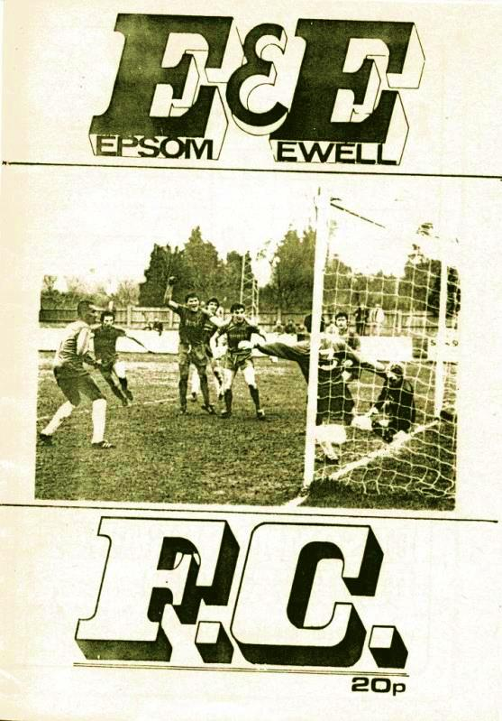
31 years ago today we extended our unbeaten League home run with a 2-0 win over Walton & Hersham. We were unbeaten for the whole of 1983 and kept it going until March, but by then we were going well and the blip against the Met Police that day had no effect on our eventual promotion in May. Tony Boorman scored a beauty from outside the area while Steve Hill got the other goal. (see programme right)

29 years ago today it was a less happy situation. Facing a drop into the relegation positions of the Isthmian League Premier Division we grasped a precious lead at half time against Tooting & Mitcham United through Mick Sorensen, son of former player Jurgen and brother of former player Erik, but the visitors fought back and scored twice in the second half and by the end of the season our all too brief stint in the top flight was over.

Surrey Senior Cup
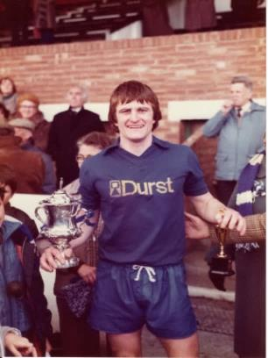
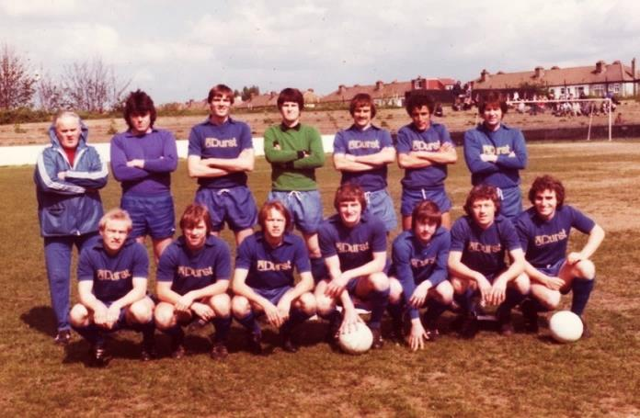
Second Round
Knaphill | 4-3 | Ashford Town (Mx)
Chipstead | 4-1 | Chessington & Hook United
Colliers Wood United | 1-3 | Whyteleafe
Corinthian Casuals | 1-1 | Egham Town
Corinthian Casuals won 4-2 on penalties
Croydon | 3-3 | Farnham Town
Farnham Town won 3-2 on penalties
Godalming Town | 1-0 | Guildford City
Horley Town | 2-2 | Badshot Lea
Badshot Lea won 4-3 on penalties
Leatherhead | 3-0 | Carshalton Athletic
Merstham | 3-0 | South Park
Met Police | 3-2 | Dorking Wanderers
Molesey | 2-1 | Raynes Park Vale
Redhill | 0-3 | Tooting & Mitcham United
Sutton United | 3-0 | Walton & Hersham
Walton Casuals | 1-1 | Kingstonian
Kingstonian won 9-8 on penalties
Westfield | 2-0 | Chertsey Town
Woking | 10-0 | Sutton Common Rovers
Third Round
Godalming Town | 12/1 | Tooting & Mitcham United
Whyteleafe | 12/1 | Farnham Town
Leatherhead | 13/1 | Kingstonian
To be played at Leatherhead F.C.
Badshot Lea | 13/1 | Merstham
Westfield | 19/1 | Woking
Met Police | 0-1 | Molesey
Knaphill | 13/1 | Chipstead
Corinthian Casuals | 12/1 | Sutton United

CCL Premier Division Club Directory
A.F.C. HAYES Telephone: 0208-845-0110 - Ground: Farm Park, Kingshill Avenue, Hayes, Middx. UB4 8DD - Colours: Blue and White Stripes/Blue/Blue

ASHFORD TOWN (Mx) Telephone: 01784-245908 - Ground: The Robert Parker Stadium, Short Lane, Stanwell, Middx. TW19 7BH - Colours: Tangerine & White Stripes/Black/Tangerine

BADSHOT LEA Telephone: 01252-320385 - Ground: Ash United FC, Shawfield Stadium, Youngs Drive, Shawfields Road, Ash, Hampshire. GU12 6RE - Colours: Claret/White/Claret

BEDFONT SPORTS Telephone: 0208-831-9067 - Ground: Bedfont Sports Club, Hatton Road, Bedfont, Middx TW14 8JA - Colours: Red & Black Hoops/Black/Red & Black Hoops

CAMBERLEY TOWN Telephone: 01276-65392 - Ground: Krooner Park, Wilton Road, Camberley, Surrey. GU15 2QW - Colours: Red & White Stripes/Blue/Red

CHERTSEY TOWN Telephone: 01932-561774 - Ground: Alwyns Lane, Chertsey, Surrey. KT16 9DW - Colours: Royal Blue & White Stripes/Royal Blue/Royal Blue

CHESSINGTON & HOOK UNITED Telephone: 01372-602263 - Ground: Chalky Lane, Chessington, Surrey. KT9 2NF - Colours: Blue/Blue/Blue

COLLIERS WOOD UNITED Telephone: 0208-942 8062 - Ground: Wibbandune Sports Ground, Robin Hood Way, Wimbledon. SW20 0AA - Colours: Blue & Black Stripes/Black/Black

COVE Telephone: 01252-543615 - Ground: Oak Farm Fields, 7 Squirrel Lane, Cove, Farnborough, Hampshire. GU14 8PB - Colours: Yellow/Black/Yellow

EPSOM & EWELL Telephone: 01737-553250 - Ground: Chipstead FC, High Road, Chipstead, Surrey. CR5 3SF - Colours: Royal Blue & White Hoops/Royal Blue/Royal Blue & White Hoops

FARNHAM TOWN Telephone: 01252-715305 Ground: Memorial Ground, Babbs Mead, West Street, Farnham, Surrey. GU9 7DY Colours: - Claret & Sky Blue /White/ Claret & Sky Blue

GUILDFORD CITY Telephone: 01483-443322 - Ground: The Spectrum, Parkway, Guildford, Surrey. GU1 1UP - Colours: Red & White Stripes/Black/Black

HANWORTH VILLA Telephone: 0208-831-9391 - Ground: Rectory Meadows, Park Road, off Hounslow Road, Hanworth, Middlesex. TW13 6PN - Colours: Red & White Stripes/Black/Black

HARTLEY WINTNEY Telephone: 01252-843586 - Ground: Memorial Playing Fields, Green Lane, Hartley Wintney, Hants RG27 8DL - Colours: Orange & Black/ Orange /Orange

HORLEY TOWN Telephone: 01293-822000 - Ground: The New Defence, Anderson Way, Court Lodge Road, Horley, Surrey. RH6 8SP - Colours: Claret & Sky Blue/Claret/Claret

KNAPHILL Telephone: 01483-475150 - Ground: Brookwood Country Park, Redding Way, Lower Guildford Road, Knaphill, Surrey. GU21 2AY - Colours: Red/Black/Red

SUTTON COMMON ROVERS Telephone: 01932-866386 - Ground: Sutton United FC, Gander Green Lane, Sutton, Surrey SM1 2EY - Colours: Yellow/Black/Black

RAYNES PARK VALE Telephone: 020-8540-8843 - Ground: Prince Georges Playing Field, Grand Drive, Raynes Park, London. SW20 9NB - Colours: Blue/Blue/Red

REDHILL Telephone: 01737-762129 - Ground: Kiln Brow, Three Arch Road, Redhill, Surrey RH1 5AG - Colours: Red and White Stripes/Black/Red

SPELTHORNE SPORTS Telephone: 01932-961055 - Ground: Spelthorne Sports Club, 296 Staines Road, Ashford Common, Ashford, Middx. TW15 1RY - Colours: Light & Dark Blue/Dark Blue/Light Blue

WESTFIELD Telephone: 01483-771106 - Ground: Woking Park, Kingfield Road, Woking, Surrey. GU22 9BA - Colours: Yellow/Black/Black

WINDSOR Telephone: 01753-860656 - Ground: Stag Meadow, St Leonards Road, Windsor, Berks SL4 3DR - Colours: Red/Red/Red

Where’s Daryl?
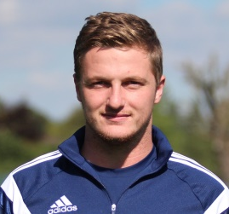
For those of you wondering where Daryl Cooper-Smith is, the simple answer, as I write, is in Thailand on holiday!

However, even if he were here, he would be unable to play for us as a result of the ramifications of our match at Bedfont Sports in November.

Daryl was given a misconduct charge after patting the Assistant on the shoulder after being sent off, which was deemed to be physical contact with an official. In addition to the two game suspension he received for his sending off, the Surrey F.A. decided to suspend him for a ludicrous amount of time and how they actually came up with the figure of 82 days is beyond me. We expect him to become available once again in late February. He was also fined £135.

Apart from the obvious over-reaction in terms of the length of the penalty imposed by the County F.A. there is in my opinion a gross injustice in suspending anyone for a number of days instead of a number of matches. For example, if we had two months of snow from this point, he wouldn’t miss any more games. Meanwhile some clubs play more, or less matches over this period of the year (cough, cough Grand Drive, Chalky Lane) and the penalty for Daryl would be far less if he were at one of those clubs. This clearly has to change for the future and we will be taking this matter up with the Surrey F.A., although we have been advised that there is no point in appealing the penalty and have regrettably had to accept their decision as it could have been increased.

Anyway, we thought it was fair to let you all know that this is why Daryl hasn’t been on the field recently!

Following on from this, both Glyn Mandeville and Matt Smith, who were also sent off that evening were fined £40 and given a two game touchline ban. They will possibly even be sitting next to you in the stand if you are at either the AFC Hayes away match, or our next home match against Ashford Town in the League Cup!

Goalkeeper’s Hall of Fame
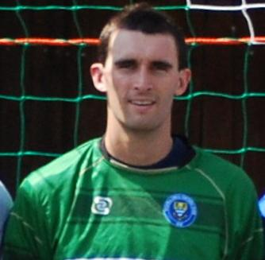
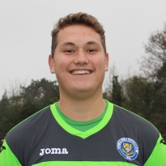
It occurred to me recently that we have a Club Hall of Fame on the website for appearances and goal scorers, but not for clean sheets kept by our goalkeepers.

So I have now added one and it is available on our website. At the top is Dave Hyatt who recorded 101 of them in 409 appearances. Michael Eacott and Adrian Jones are also on the list with 17 and 7 respectively and of course we hope they continue to climb the list.

As the top of the list looks a long way away and a bit daunting, I told Michael that his clean sheet percentage is better than Dave’s was. Unfortunately, our failure to keep one at Horley Town means that is no longer the case. Sorry big fella

Club Statistical History - (including Horley Town match on 28/12/15):
League: Played: 2,817, Won: 1,154, Drawn: 536, Lost: 1,127
For: 5,178, Against: 5,005, GD: plus 173 - Win Ratio 40.97%

CCL only: Played: 396, Won: 180, Drawn: 78, Lost: 138
For: 712, Against: 619, GD: plus 93 - Win Ratio 45.45%

Cup and Other (inc Abandoned Matches):
Played: 1,096, Won: 518, Drawn: 128, Lost: 442 Abandoned: 8
For: 2,376, Against: 2,052, GD: plus 324 - Win Ratio 47.26%

Under Glyn Mandeville: Played 65, Won: 34, Drawn: 10, Lost: 21
For: 132, Against: 106, GD: plus 26 - Win Ratio 52.31%

Total: Played 3,913, Won: 1,672, Drawn: 664, Lost: 1,569, Aban: 8
For: 7,554, Against: 7,057, GD: plus 497 - Win Ratio 42.73%

First Senior Match: 30th August 1924.
Lost 1-3 vs Dorking at our home ground at the time of Horton Hospital Grounds.

First Match Programme Issued: 15th September 1923.
Won 4-0 vs West Norwood Reserves - Friendly match at Horton Hospital Grounds.

Number of Official Home Grounds: Six.

Alexandra Recreation Ground 1918-1922,
Horton Hospital Grounds 1922-1925,
West Street 1925-1993,
Merland Rise 1993-2010,
Moatside 2010-2012,
High Road 2012- present.

Record Win: 12/10/1935 - 13-1 v Reigate Priory (H) - Amateur Cup.

Record Defeat: 14/02/1948 - 0-14 v Chelmsford City Reserves (A) - London League.

Longest Serving Manager: 1) Adrian Hill 853 1982-1985 & 1990-2003
2) Pat O’Connell 466 1973-1982
3) Lyndon Buckwell 407 2006-2014
4) Ricky Kidd 190 1986-1990

Record Appearances: 1) Graham Morris 658 1990-2004
2) Nigel Bennett 630 1989-2005
3) Tommy Tuite 582 1973-1987
4) Ernie Watkins 419 1945-1960

Record Goal Scorers: 1) Tommy Tuite 391 1973-1987
2) Reg Marlow 254 1924-1936
3) Kyle Hough 188 2007-present
4) Jimmy Jones 148 1933-1945

Most Appearances in a season: Tony Coombe and Tommy Tuite - 59 in 1980/81.

Most goals in a season: Reg Marlow - 65 (at least) in 39 appearances in 1926/27.

Senior League Titles: 5 - 1925/26 Surrey Senior League - 1926/27 Surrey Senior League - 1927/28 London League - 1974/75 Surrey Senior League - 1977/78 Isthmian League Division Two

Combined Counties League Premier Division Opponents
All-time Records
incl Monday 28th December | P | W | D | L | F | A | PPG | GD | Best  Win | Worst  Loss
Sutton Common Rovers | 10 | 8 | 1 | 1 | 24 | 11 | 2.50 | +15 | 4-0 | 1-4
Spelthorne Sports* | 4 | 3 | 1 | 0 | 13 | 5 | 2.50 | +8 | 6-2 | -
Horley Town | 27 | 19 | 5 | 3 | 59 | 26 | 2.30 | +33 | 6-0 | 1-3
Westfield | 17 | 11 | 3 | 3 | 39 | 27 | 2.12 | +12 | 6-1 | 0-4
Colliers Wood United | 21 | 14 | 2 | 5 | 45 | 28 | 2.10 | +14 | 4-0 | 0-3
Knaphill | 5 | 3 | 1 | 1 | 10 | 6 | 2.00 | +4 | 4-1 | 1-2
Bedfont Sports | 8 | 4 | 2 | 2 | 12 | 10 | 1.75 | +2 | 3-0 | 0-4
Guildford City | 15 | 8 | 1 | 6 | 27 | 21 | 1.67 | +2 | 4-0 | 1-5
Farnham Town | 12 | 6 | 2 | 4 | 21 | 21 | 1.67 | 0 | 3-1 | 1-4
Raynes Park Vale | 25 | 12 | 5 | 8 | 54 | 36 | 1.64 | +18 | 6-1 | 0-2
Hanworth Villa | 13 | 6 | 3 | 4 | 31 | 22 | 1.62 | +9 | 5-0 | 1-4
Hartley Wintney | 9 | 4 | 3 | 2 | 25 | 16 | 1.60 | +9 | 5-0 | 2-4
Camberley Town* | 86 | 38 | 20 | 27 | 155 | 119 | 1.56 | +36 | 9-1 | 0-4
Chessington & Hook | 27 | 11 | 9 | 7 | 52 | 41 | 1.56 | +11 | 6-0 | 1-3
Cove | 33 | 14 | 9 | 10 | 74 | 55 | 1.55 | +19 | 7-0 | 1-6
Windsor | 46 | 18 | 12 | 16 | 86 | 86 | 1.43 | 0 | 4-0 | 0-6
Badshot Lea | 16 | 6 | 3 | 7 | 27 | 32 | 1.31 | -5 | 3-0 | 0-4
Redhill | 32 | 13 | 2 | 17 | 60 | 69 | 1.28 | -9 | 7-2 | 2-8
Chertsey Town | 46 | 16 | 5 | 25 | 65 | 83 | 1.15 | -18 | 3-0 | 0-7
Ashford Town (Mx) | 16 | 4 | 2 | 10 | 22 | 41 | 0.88 | -19 | 3-0 | 0-5
AFC Hayes | 7 | 1 | 2 | 4 | 9 | 15 | 0.71 | -6 | 3-1 | 0-3
Grand Total | 476 | 220 | 91 | 164 | 896 | 772 | 1.58 | 124 | - | -
* includes one abandoned match v Camberley and one loss on penalties v Spelthorne

Latest Results Grid
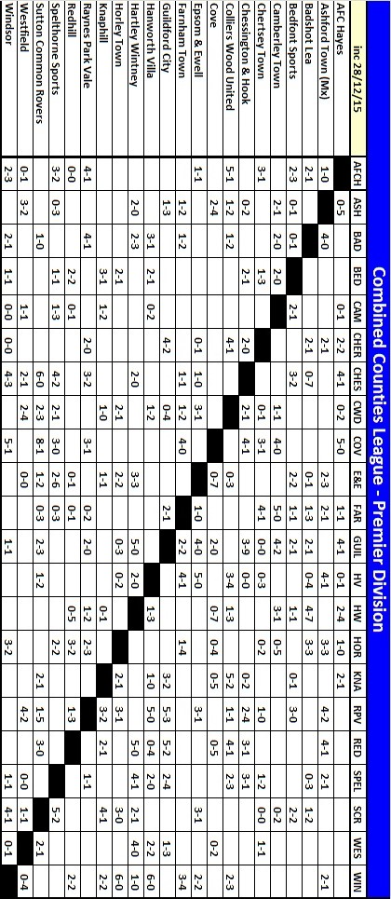

Centre page for results

Centre page for results

Redhill F.C. – History
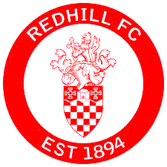
Redhill football club is steeped in a rich history and prides itself on tradition.

It all started for the club back in 1894, after a meeting between prominent local businessmen in the Warwick Hotel and shortly after, a friendly match was arranged against a Dorking side. That game ended in a two all draw and was played at the clubs original home at Wiggie. A ground lent to the club by their goalkeeper, Mr. H Trower.

Two years later, the club moved into its stadium of 88 years at Memorial Park in the centre of Redhill. At the time, the ground was an open swamp, until proper drainage was installed, which was accomplished under the auspices of a Sports Ground Association, an organisation that lasted until 1919.

For the first few years, the club only competed in friendly matches but that all changed in 1898, when Redhill Football Club entered the South Suburban League, followed by various other leagues that have since folded.

It didn't take long for the Reds to make an impact; The club were Champions of the East & West Surrey league in 1902/03, and two years later, lost in the Surrey Senior Cup final.

THE 'GLORY' YEARS

In 1922, the club gained acceptance to join the prestigious London League, which acted as a stepping stone for the club, when they became members of the Athenian League. Success came early in the Athenian League, finishing runners up in their first season, and becoming champions in 1924/25.

The following year, the club enjoyed what was possibly its best season ever, reaching two cup finals and the semi-final of the FA Amateur Cup, losing 7-1 to Northern Nomads at Highbury in front of 17,000 people. A possible contribution to the final result of that game was the fact that Redhill lost their goalkeeper very early on with a severe jaw injury.

CRIES OF 'REDHILL'

IN FACT that game sparked off an unusual football tradition that can still be heard today. Without a 'keeper and down to 10 men, Redhill were reduced to kicking the ball out the ground every time the Nomads attacked and each time, a cry of "Redhill!" was screamed by the supporters of both sides.

Over the years this spread around the entire country as both Redhill and the Nomads travelled the land, and when war broke out in 1939, the troops took it abroad. Next time you're at a game, anywhere in the world and the ball is booted out of the stadium, you might just hear someone shout "Redhill!"

In 1928/29, Redhill won the Surrey Senior Cup with a 3-2 over Epsom Town (who later became Epsom & Ewell). The match was played at Josephs Road, Guildford in front of four and a half thousand people.

Redhill, despite being a non-league side, were once one of the most feared teams in the south of England. Non-league football was a completely different game in years gone by, and gap between the amateurs and the professionals was much smaller than it is today.

In April 1948, Redhill faced Chelsea in a friendly match at the memorial sports ground and the Reds came away as 4-2 winners. Of course, Chelsea weren't the force that they are now, but they did field an English International by the name of Len Goulden. When this match took place, Redhill were bottom of the Athenian League.

A year later, Redhill lost 1-0 against Arsenal. The match was friendly offered by the London side in return for Redhill providing the Gunners with two of their most talented players at the time; Colin Grimshaw and Bernard Sexton. Grimshaw also spent time with Epsom.

Further success was a long time coming, but it was well worth the wait, in 1957/58, the club reached the 1st round proper of the FA Challenge Cup. They defeated Tooting & Mitcham in the 4th qualifying round and were rewarded with a trip to Carrow Road against Football League side, Norwich City. The Canaries came out as 6-1 winners, but many write-ups at the time gave Redhill lots of credit for the manner of their performance.

In the 1960's, A very talented youngster by the name of Ray Hutchins played for Redhill. Not many people in football circles will know the name, but in 1963/64, he won two England youth caps whilst playing for Redhill. The other players in the squad were playing for top professional clubs, and one of players was a certain Harry Redknapp playing at the time for West Ham United.

During the 1970's, the club was inconsistent in the Athenian league. League placings of 6th, 10th, 7th, 2nd to bottom, 12th, 10th again, 12th again, 11th, Bottom, and second to bottom completed the decade.

THE END OF AN ERA

As the Athenian League drew to a close in the early 80's, so too did Redhill football clubs home. The 1983/84 season saw Redhill win the last ever Athenian League title, but the club were unable to take their place in the higher league, Redhill were asked to move out of the Memorial Ground and move to a site two miles south, to Kiln Brow, where facilities were non-existent. (Memorial Ground pictured below)

The area once known as the Memorial sports ground remains as an open park space but if you know where to look, you can still see evidence of where the main stand was situated.

The club took their place in the London Spartan league, but times at Kiln Brow were tough. Samples taken at the time have shown that the soil on the pitch was made up of more clay than actual soil. So much so, that even worms couldn't live in it! But the club battled on with ups and downs and over the years, the hard work of many individuals has kept the club alive.

In July 2007, non-league legend Tommy Sampson (who won the last old Wembley F.A. Vase final with Deal Town) was appointed Manager with former Kingstonian and Bromley Manager Stuart McIntyre becoming 1st Team coach. Half way through the season though, Tommy unfortunately suffered a stroke and Stuart McIntyre took over first team affairs with the help of Jeremy Jones. The team reached the semi-finals of the Sussex RUR Cup and the Surrey Senior Cup. In October 2008, McIntyre decided to step down and take on a less demanding role due to personal and work commitments. The club appointed former Brighton & Hove Albion player, John Crumplin as manager and McIntyre stayed on as his assistant.

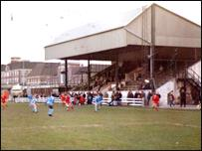
A new 162 "Alan Thurlbeck" stand, with facilities for disabled fans was built in the summer of 2008 and work continues on the development of the ground with new turnstiles and a new outside toilet block.
In 2009/10 former Epsom and Ewell and Redhill player Marcus Alcindor became Manager, leading the club to 5th place in the Sussex League for the 2009/10 season.

Another change in management the following season saw Steve Johnson take over half way through, but with a handful of games left to play, he too parted company with the club paving the way for another man to take over the reins.

Simon Colbran's time as Redhill manager was short lived, and Michael Maher, Redhill's youngest ever manager, moved up the ranks from Youth Team manager to First Team manager in early 2012. He took the club up to the Ryman League in 2012/13 where they remained for two seasons before being relegated with Maher sacked. However, their first season in the Combined Counties League started badly and the new Manager Perry Gough resigned with Maher returning in a caretaker role.

Previous Matches against Redhill
We have played Redhill on 32 occasions in our history, but many of these matches were significant ones as we were rarely in the same League, so would meet as local rivals in the F.A. Cup, Amateur Cup and County Cup, often watched by thousands of spectators before the war.

The first time we ever met was over 90 years ago, on 15th November 1924 for an Amateur Cup tie. It was our first ever season in the competition, but despite beating West Norwood to reach this stage, Redhill were far too strong, triumphing easily 5-0. The game was an Epsom home game, but it had to be switched to Redhill because the Horton Sports Ground did not allow the Blues to take a “gate”.

The following year they met at our new ground at West Street in the East Surrey Hospital Cup, but Redhill still won easily 8-2. In March 1928 Epsom gained revenge 7-2 in the same competition, the first defeat Redhill had ever suffered in its eight-year history. However in November of the same year they had defeated us 2-1 in the Surrey Charity Shield at the Memorial Ground, despite a goal from Herbert Etheridge.

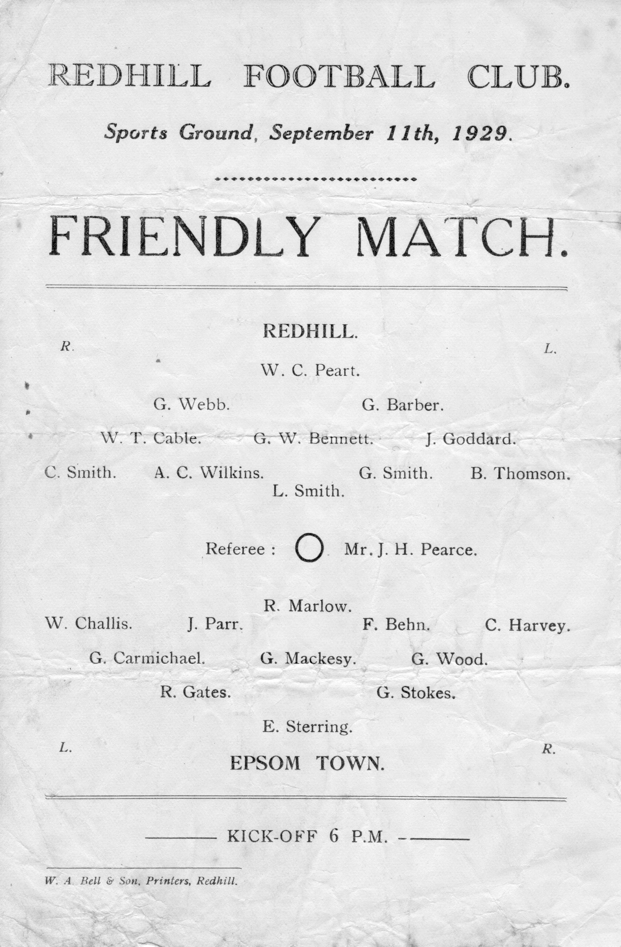
The Surrey Senior Cup Final of 1929 at Guildford City’s Josephs Road ground was a big game and was watched by 4,600 interested spectators and we led at half time through our left winger Wilfred “Bronk” Challis, but three goals in a ten minute spell, the first of which was a harsh penalty, left the Blues too much to do, and although Bob Earl reduced the deficit with fifteen minutes to go, it was too much to retrieve.

We lost a friendly there in the September of 1929 (see programme left) and Redhill defeated us again a month later as our Amateur Cup run ended at a familiar hurdle. All in all, the Lobsters would knock us out of this competition on eight occasions, while we won just three of the ties. The first of these was in a final qualifying round Amateur Cup tie that we

won 2-1 on 21st November 1931 at Redhill in front of 4,000 with goals from Leslie Graves and Harry Payton (see programme right).

That win earned us a visit to the First Round Proper where we would travel to and defeat Ipswich Town 4-2 but that story is for another day!

The win turned fortunes around in these meetings and after losing six of our opening seven contests, we now embarked upon a run of our own, containing five wins and a draw from the next six.

The next of these came on 1st October 1932 in the F.A. Cup when two goals each from Tommy Dunne and Billy Williams, three of which came in the second half, ensured a 4-1 win at West Street.

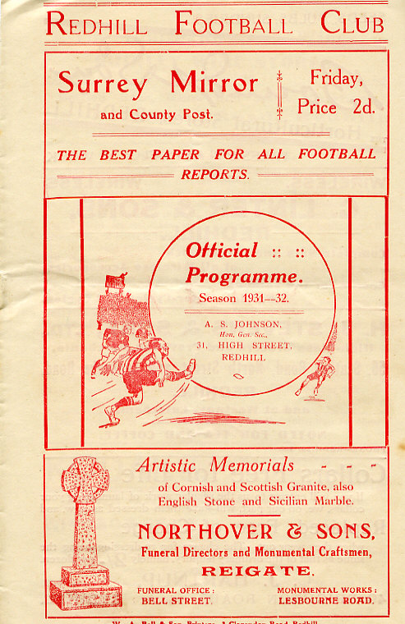
Almost one year on we repeated the scoreline in the Amateur Cup, this time with Leslie Marlow scoring a hat trick in front of just under 3,000 spectators at West Street. The most I ever saw at West Street was 1,800 and the ground was packed, so I’ve no idea how 3,000 or sometimes even more could have got in there and actually been able to see the match too!

The following season we travelled there in the F.A. Cup where on 15th September 1934 we defeated them 6-3. Unfortunately our attempts to reach the First Round of the F.A. Cup for the second season in succession were thwarted by Guildford City a couple of rounds later.

However, we made it a double of sorts by then knocking them out of the Amateur Cup by three goals to one, following a 1-1 draw at the Memorial Ground in the November, with Tommy Dunne on target in both matches.

But all good runs have to end and in 1935/36 we were not such a good team. We had recorded a club record 13-1 win over Reigate Priory in the Amateur Cup but Redhill

knocked us out 2-0 at West Street in the following round with a goal in each half.

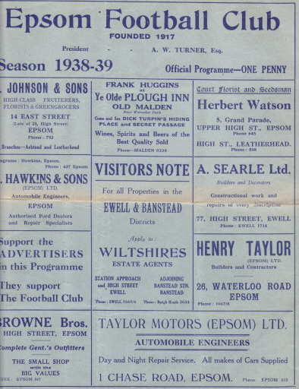
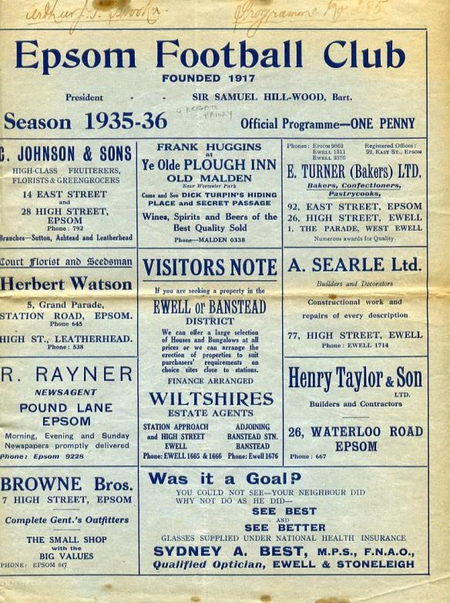
They then repeated the score line later that season, again at West Street in the Semi-Final of the Surrey Charity Shield (see programme left)

Heavy Amateur Cup defeats followed in 1936/37 and 1937/38 by three clear goals at Redhill and 4-1 at home in the later match. The tide had turned against us and although we were a decent side again by that point, the Lobsters as they were better known back then, were stronger.

A goalless first half at Redhill on 11th December 1937 turned into a 4-2 Surrey Charity Shield loss and by the time of the 1938/39 season

we marked our sixth straight meeting in the Amateur Cup with a narrow 2-1 home defeat after extra time; the opening 90 minutes having failed to produce a goal. (see programme right). Then one week later they returned to knock us out of the F.A. Cup too, this time by the more decisive score of 4-1.

Maybe thankfully this was the last time that the two teams met before World War Two ensured little contact, although the Epsom Town team that rented West Street for the duration of the hostilities did meet them twice in our inaugural season in the South Eastern Combination, although the wins that each home team procured were futile as Redhill withdrew from the league in November 1940.

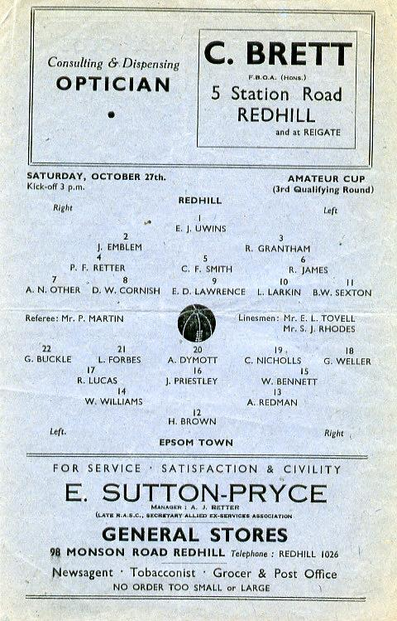
Upon resuming football we defeated them home and away in friendly challenge matches during 1945/46 but once we were back into the big matches, we were found lacking, and 3,000 people watched us get beaten 5-0 at the Memorial Ground in the Amateur Cup on 26th October 1946, even though the programme had the date wrong and the round of the competition too! (see programme right)
Further defeats followed. Another Surrey Charity Shield defeat came our way on 20th March 1948, albeit narrowly, 2-1 after extra time, and we then had to wait seven years for our next meeting in the Final Qualifying round of the Amateur Cup. Despite our previous two wins at this stage we were edged out 2-1 at the Memorial

Ground despite Dave Hermitage’s second half goal we were unable to equalise, having trailed by two goals at the half in front of 4,000 spectators. (see programme left)

This would be our last meeting for many years. Maybe the geographical boundaries changed but it seems bizarre that after meeting so frequently in previous years that it would be nineteen years before we would again meet.

Of course, part of the reason for this was that Redhill had an exemption in the Amateur Cup, while we were a much poorer side throughout the sixties and early seventies so were usually out before they had joined the competition!

Our next meeting, also in the F.A. Cup, ended in defeat, despite the fact that we were a very good team that year. The 1974/75 season will be remembered for many things but it won’t be for our F.A. Cup run as we may have started our season off with eight straight league games with a goal difference of F26 A1 but this didn’t bother Redhill, and although later in the season we would beat other teams from their division in our famous Vase run, we were no match this day and crashed 3-0.

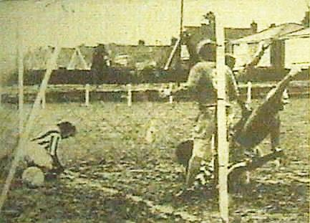
We were on the rise by that time and eventually found ourselves promoted into Redhill’s division for the 1976/77. After all these years we were finally at the same level and we drew 2-2 over there before winning 1-0 in the return on New Year’s Day 1977 with former Redhill player Alex Reid scoring our goal. (see below)

In between that we also won a Surrey Senior Cup tie at Redhill in December 1976 by five clear goals and so it transpired that on our last visit to the Memorial Ground we recorded our biggest ever victory there.

Along with many clubs at the end of the season we were accepted into the Isthmian League, but in the first sign of concern about their ground, they were not accepted, despite finishing in midtable. In 1984 they won the Athenian League in its final season but were again unable to follow the majority of its clubs into the Isthmian League due to the loss of their ground that season and since that time they have been at Kiln Brow; a very basic ground in its early days, although much better appointed now.

They had to spend time kicking around in the London Spartan League and then in 1987 moved into the Sussex League, where they remained for a number of years. During that

time we met twice more in the Surrey Senior Cup, on 23rd October 2001 and on 20th January 2009. Both matches were played at our home ground of the day, Merland Rise and both were won 3-0 with one goal in the first half and two in the second!

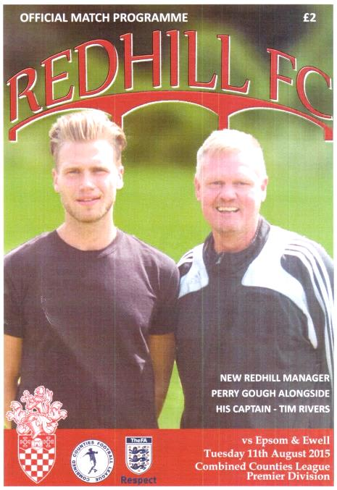
This brings us almost up to date. Redhill finally achieved their membership of the Isthmian League in 2013, although two seasons at that level culminated in relegation to our league and we became their opening visitors back on 11th August, taking the points thanks to a second half Kyle Hough strike. (see programme left)

Although we will surely never again have meetings watched by the numbers that used to attend years ago when the two teams used to be regular rivals, it would be nice to see them a few more times in the future, although if things stay as they are, Redhill may find themselves in Step Six which would be a disaster for the famous club. I hope that they are able to turn things around soon. Starting next week, of course!

#loveastat
Thanks to Tony Coome, a supporter for the last few years and no connection to our former player and Assistant Manager, who mentioned that our first goal against Sutton Common Rovers was our fiftieth League goal of the season. It got me thinking, when had we last done this?

There are two ways of answering this question. One of these is by a certain date. Did you know that we have NEVER scored fifty League goals before Christmas before!! This really caught me by surprise!

The other way is in terms of the number of league matches required to reach fifty goals, we took 21 this season. We also did this in 2007/08 but had only scored 50, while this year we have scored 52, so I went further back and it took me further than I thought, all the way back to 1974/75, when we reached fifty goals in our thirteenth match!

Even that isn’t our club record as in 1926/27 we got there in just our tenth match, on the way to recording a club record 115 goals in just a 24 game season! Obviously goals were a little easier to come by in those days and we beat our current 21 game mark for 14 seasons in a row from 1925-39! However, apart from 1926/27 and 1974/75 we have never broken 100 and at the half way stage this term we are at 52, so here’s hoping!

Every Opponent A-Z
Over the years we have played many, many different opponents. Exactly how many is a difficult question, as it all depends on your definition. Are Camberley & Yorktown different to Camberley Town, or are Epsom Town different to Epsom F.C. or Epsom & Ewell F.C.?

In my analysis I have classed them as the same team, and will work through them all from A to Z. Some we have played many times, whilst others we have met just once or twice. Enjoy!

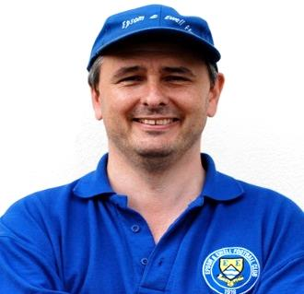
Rest of London League: Played 1 - W1 D0 L0 - F3 A0 - PPG - 3.00 - Perfect

Back in 1927/28 we won the London League for the one and only time in our history, although we would be runners-up on five other occasions. As was customary in those days, we hosted a team of players representative of all the other teams in the League to open our season and we beat them 3-0, proving that a team is usually better than a group of individuals. Nothing changes!

Ringmer: Played 2 - W1 D0 L1 - F4 A2 - PPG - 1.50 - Average

Ringmer have been a Sussex League club for many years, but our paths have stayed fairly distant. Our two meetings both came in the F.A. Vase, the first of which was in 1977/78 when we hosted them in a Third Round tie, winning 4-0 at West Street with two goals from Steve Delaney, added to others from Tony Coombe and Richard Parkin. This put us in the Fourth Round for the first time since our Wembley run three years previously where we bombed out 0-3 at home to Eastbourne United; a team we beat easily home and away in the League that season!

They had to wait 34 years to get their revenge, defeating us 2-0 at the Anchor Ground in a second qualifying round tie in a match where the opposition belied their lowly league position and two second half goals did for us when for a while it looked as though we might hold out at 0-0. Until Dre Grobler was harshly sent off, that is!

We have also visited for a pre-season friendly, winning 2-0 in 2003/04 and they continue in the Sussex League, now renamed the Southern Combination, to this day.

Romford: Played 4 - W1 D1 L2 - F9 A17 - PPG - 1.00 - Poor

After the Second World War, Romford were a very big club. They played at Wembley Stadium in the first Amateur Cup Final to be played at Wembley Stadium in 1949 in front of 100,000 spectators, losing 1-0 to Bromley and were a powerful Isthmian League giant before turning professional, joining the Southern League and even submitting numerous applications to join the Football League in the days when promotion wasn’t automatic. Before the war they spent a couple of years in the London League from 1929-31, which is where we met them. They played then, as in the glory days, at the enormous Brooklands ground; a half football and half greyhound racing facility in front of enormous crowds, even back then.

Our first meeting was at West Street on 14th September 1929, where we led 4-0 at half time but had to settle for a 4-2 win. The reverse situation happened on our first visit to the Essex ground as we too trailed by four goals at the interval, and although we also got two goals back, we still lost 5-2.

The following season we trailed 2-1 at half time at West Street but managed to record a 3-3 draw in the end, but the strangest meeting between the clubs was our last, on 14th March 1931 at Brooklands. An even match was level at half time and remained goalless after an hour, yet somehow Romford had scored seven times to win 7-0 by the final whistle!

Romford’s ambition proved to be their downfall. Owning a massive ground had enormous overheads and the plan was to move to a nice new more modern ground in the late seventies, but the move never came. They sold their ground in 1975 and were allowed to remain until 1977 but with a new ground hardly started and money running out they folded in 1978.

But they weren’t quite done yet. In common with other big Southern League clubs of the day like Bedford and Maidstone they reformed, joining the Essex Senior League in 1992. They merged with Collier Row in 1995/96 but within two seasons they were just renamed Romford as they effectively and clinically usurped their former landlords. However, success was hard to come by and they also lost the Sungate ground. They dropped out of the Isthmian League early in the new Millennium but returned in 2009 and have been there since, ground sharing currently with Thurrock F.C. right next door to the M25.

I am guessing that they still harbour plans to secure a ground of their own, although if I were Thurrock, I’d be worried after what happened to Collier Row!

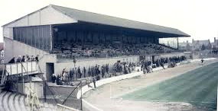
How about that for a main stand! The main feature of the Brooklands ground

Royal Artillery Mechanical Corps Aldershot: Played 1 - W1 D0 L0 - F3 A0 - PPG - 3.00 - Perfect

We only met this armed forces unit once, in the F.A. Cup Extra-Preliminary Round on 4th September 1937 winning 3-0 but we didn’t break through until the second half as Jackie Pullen scored twice and Jimmy Jones got the other one from the spot.

Royal Electrical Mechanical Engineers Putney: Played 1 - W1 D0 L0 - F9 A2 - PPG - 3.00 - Perfect

In 1945/46 we had of course just reformed after World War Two and were in a small London League division of nine teams, which became eight following the withdrawal of Acton. There were many dates for friendlies and many armed forces teams still in existence, of which one was the Putney based Mechanical Engineers, but they were badly out of their depth and were crushed 9-2. Gordon Brogdale would score 44 goals in 32 appearances for us this season, the sixth best seasonal tally in our history and he scored five of the goals here with Frank Adey (2), Syd Tingey and an own goal completing the formalities! Friendlies were classed as official challenge matches up until 1960 in our records as the club counted them back then and who am I to disagree!

Royal Naval Depot, Chatham: Played 13 - W11 D0 L2 - F48 A18 - PPG - 2.54 - Fantastic

Held over to next issue

Player Sponsorship
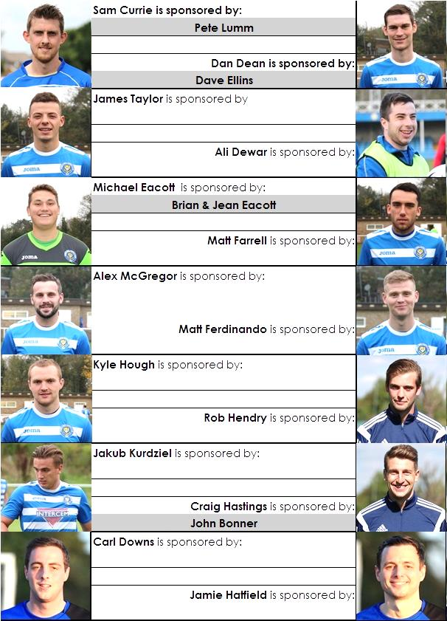

Here is the current list for the 2015/16 season showing all of our players and Management that are currently available for sponsorship this season.

Sponsorship costs just £40 and it is easy to do. Just select a player who has not been previously sponsored and let a Committee Member know that you would like to sponsor them. Beware though. Until we have received the money it is possible for someone to jump in front of you, so don’t delay, sponsor today!

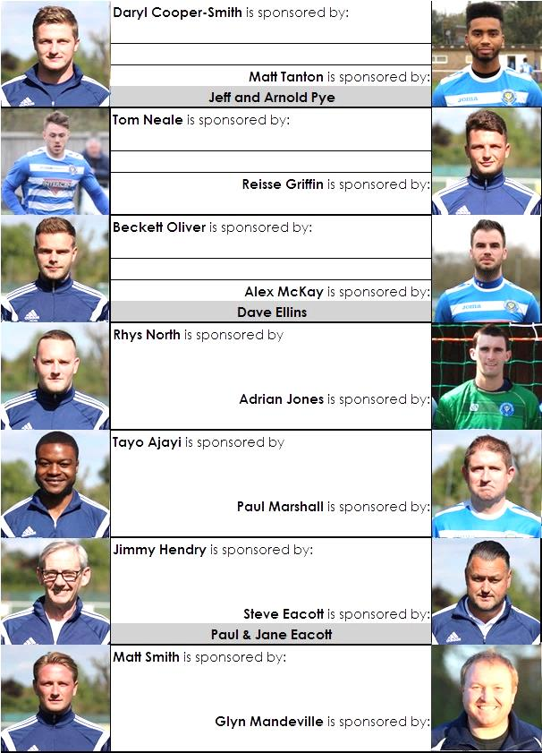

F.A. Vase
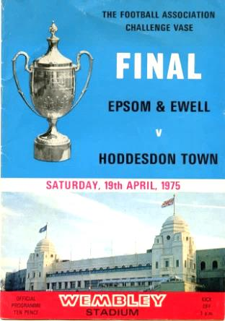
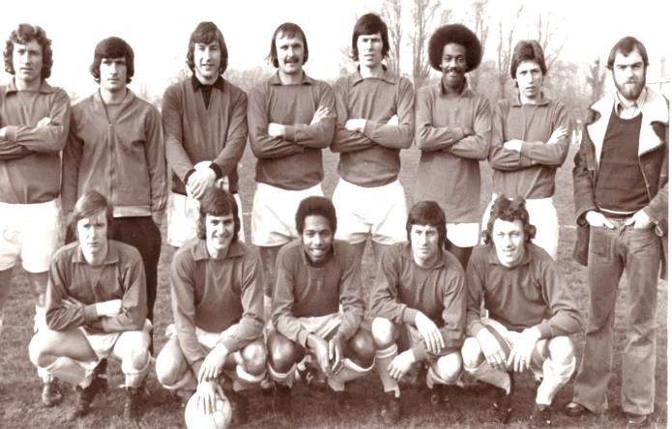
Third Round – Original date for fixtures – 12th December
Marske United | 5/1 | Team Northumbria
Sunderland RCA | 4-0 | Tadcaster Albion
Newton Aycliffe | 5/1 | Atherton Collieries
South Shields | V | Morpeth Town
North Shields | 1-1+ | Runcorn Town
Dunston UTS | 5/1 | Seaham Red Star
Alsager Town | 0-2 | AFC Wulfrunians
St Andrews | 1-5 | Leicester Nirvana
Handsworth Parramore | 1-2 | Cleethorpes Town
Pinxton | 3-4 | Nuneaton Griff
Walsall Wood | 0-3 | Alvechurch
Uttoxeter Town | 3-4 | Coleshill Town
Hereford | 2-0 | Brocton
Saffron Walden Town | 2-3 | Berkhamsted
FC Broxbourne Borough | V | Bowers & Pitsea
Hullbridge Sports | 2-0 | Stanway Rovers
AFC Dunstable | 4-0 | Basildon United
Edgware Town | 0-3 | Ipswich Wanderers
Yaxley | 3-4+ | Sleaford Town
Hertford Town | 0-2 | FC Romania
Colliers Wood United | 1-3 | Hartley Wintney
Thame United | 1-2 | Kidlington
Ascot United | 0-0+ r1-4 | Camberley Town
Lordswood | 1-5 | Ashford United
Eastbourne Town | 2-3 | Sutton Common Rovers
Tadley Calleva | 2-2+2-4+ | Newport (IOW)
Canterbury City | 1-3 | Knaphill
Moneyfields | 0-0+ r29/12 | Brimscombe & Thrupp
Buckland Athletic | 1-2 | Bradford Town
Highworth Town | 1-5 | Salisbury
Welton Rovers | V | Bodmin Town
Bristol Manor Farm | 7-1 | Hengrove Athletic

F.A. Vase
Fourth Round – 9th January
Cleethorpes Town | V | Alvechurch
Northern Counties East – 7th |  | Midland – 2nd
Hereford | V | Leicester Nirvana
Midland – 1st |  | United Counties – 1st
South Shields / Morpeth Town | V | North Shields / Runcorn Town
Coleshill Town | V | Dunston UTS / Seaham RS
Midland – 13th
AFC Wulfrunians | V | Nuneaton Griff
Midland – 7th |  | STEP 6 - Midland Division 1 – 3rd
Sunderland RCA | V | Sleaford Town
Northern – 8th |  | United Counties – 11th
Newton Aycliffe / Atherton | V | Marske / Team Northumbria
FC Broxbourne Borough /  Bowers & Pitsea | V | Sutton Common Rovers
 |  | Combined Counties – 14th
Kidlington | V | Knaphill
Hellenic – 2nd |  | Combined Counties – 11th
Newport IOW | V | Ashford United
Wessex – 9th |  | Southern Counties East – 3rd
Moneyfields /  Brimscombe & Thrupp | V | Bristol Manor Farm
 |  | Western League – 1st
FC Romania | V | Camberley Town
Essex Senior – 4th |  | Combined Counties – 4th
AFC Dunstable | V | Salisbury
South Midlands – 2nd |  | Wessex – 2nd
Berkhamsted | V | Hullbridge Sports
South Midlands – 4th |  | Essex Senior – 10th
Hartley Wintney | V | Bradford Town
Combined Counties – 1st |  | Western League – 8th
Welton Rovers / Bodmin Town | V | Ipswich Wanderers
 |  | Eastern Counties – 12th

Epsom & Ewell F.C. Club History 1918 - 2015
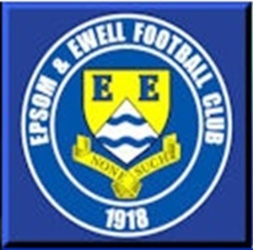
We were founded in March 1918 as Epsom Juniors Cricket Club and played throughout the summer. In the autumn, Epsom Juniors F.C. came into being and played a handful of games from what is now known as Alexandra Recreation Ground. Competitive football followed as we entered the Surrey Junior League in 1919, and became founder members of the Sutton & District League in 1920.

A change of name in July 1922 to Epsom Town F.C. heralded the start of a very successful era. By now resident at the Horton Hospital Sports Ground, we were unfortunate to lose 2-1 after extra time at Dorking F.C.’s Pixham Lane ground to Caterham Mental Hospital in a replay of the Surrey Junior Cup Final. However, we won three other trophies that season, the Leatherhead Hospital Shield, the Sutton Hospital Cup, and the Epsom Hospital Cup. In addition, we also won the Sutton & District League, and under the forward thinking of their visionary Chairman Hugh Bradley, took the step into Intermediate Football, where we won the Southern Suburban League without losing a match. Senior football was granted as we were unanimously accepted into the Surrey Senior League for 1924/25, where we finished third.

In September 1925, the club relocated to the old Ewell F.C. ground at West Street, which was purchased through the generosity of our future President Robert Bradshaw. In 1925/26 the Championship of the Surrey Senior League was attained, and the following season, we defeated Egham 1-0 at Egham in the League Charity Cup to complete a League and Cup “double”.

Election to the London League followed, and the title was claimed in the first attempt in 1927/28. Unfortunately, we were unable to repeat this, instead finishing runners-up in 1931/32, 1932/33, 1934/35, 1936/37 and 1937/38. Cup Honours were limited, although in 1929 Redhill defeated us 3-2 in front of 4,600 at Guildford in our first Surrey Senior Cup Final, having seen off Wimbledon 4-1 in the semi-final!

The thirties were a very successful era, and we won the Surrey Charity (Senior) Shield in 1933 with an impressive 5-0 win over Woking at Kingfield. However, the proudest moment of our pre-war history was an appearance in the First Round Proper of the F.A.Cup in 1933/34. Woking, Nunhead, Tooting & Mitcham, Beddington Corner, and Leytonstone were defeated, and a crowd of 9,485 at the Lea Bridge Speedway Stadium witnessed a 4-2 loss against the hosts Clapton Orient. At the end of that season we changed our name to Epsom F.C.

In 1939 a newly formed team, Epsom Town (no connection to the earlier name) shared the ground with Epsom F.C. However, this arrangement was suspended when war was declared, and we folded for the duration. In the meantime, Club Chairman Charles Pettett threw in his lot with Epsom Town in an attempt to boost morale by keeping the football flag flying. It was successful, as that club competed continuously throughout the war years, winning the Surrey Combination in 1939/40, and reaching the Surrey Senior Cup Final in 1944, losing 3-1 to Tooting & Mitcham, at Sandy Lane. After the war, Epsom F.C. restarted, continuing in the London League and reclaimed West Street. Temporary homes were found for Epsom Town while they competed for a season in the newly created Corinthian League, but disbanded in 1946.

In 1949 we entered the Corinthian League ourselves, where in 1952 we reached the League Memorial Shield Final in 1952, going down 2-1 to Champions Hounslow at Eastbourne after leading at half-time. Things improved further with the signing of the former English Amateur International Pat Lynch from Hendon, finishing third in 1952/53, while in 1954 we reached the Surrey Senior Cup Final for the second time in our history, losing unluckily 2-0 to Corinthian Casuals in front of 6,159 at Selhurst Park. In 1955 we won the Surrey Senior Shield with a 1-0 win over Carshalton Athletic at West Street.

We appointed our first ever Manager, Kingstonian legend Doug Whitehead in 1955 and the Corinthian League double was almost achieved in 1956/57, but two losses in the final week, along with a 2-0 defeat in the Cup Final to Maidenhead United at Dorking ensured that we ended with neither, finishing fourth. However in 1960, we finally raised the Shield with a 2-0 revenge win over Maidenhead at Vale Farm, home of Wembley F.C.

In 1960 we changed our name once again to Epsom & Ewell F.C. This was not because of any merger with Ewell & Stoneleigh as is often quoted, but was an attempt to increase support across the whole of the Borough. In 1963 the Corinthian League merged with the Athenian and Delphian Leagues, and we were placed in Division One of the new structure, but the sixties were full of poor results and we were relegated in 1965.

Despite a string of managers, most notably ex-Leyton Orient winger Jimmy Smith, and Tony Williams, now famous for his creation of the F.A. Yearbooks, our fortunes did not improve significantly and further relegations were avoided in the early seventies by the benefit of re-election. However in 1973, despite “improving” to finish second from bottom, the Athenian League ran out of patience and cut us loose. This was unfortunate timing as

we had just cleared all of our debts, and in addition to a virtually new Committee, former Fulham player Pat O’Connell had taken over as Manager.

The Surrey Senior League took us in at the last minute, and the new squad, including young striker Tommy Tuite, won the League Cup, and the following season, 1974/75 achieved a second Surrey Senior League “double”. However, the season would always be remembered for reaching the Final of the inaugural F.A. Vase, where 9,500 saw the Blues edged out 2-1 by Hoddesdon Town at Wembley Stadium. The Athenian League welcomed us back, and promotion to the top flight was achieved in that first season. In 1976/77 we reached the Athenian League Cup Final, losing 1-0 at Chalfont St Peter.

For 1977/78 many clubs were invited to join the expanding Isthmian League, and we were placed in the new Division Two. Our first match under floodlights took place against Met Police, and the title was clinched the following April. In 1979/80 we won the Southern Combination Cup 7-2 over Hampton on their own pitch, where the opposition were blitzed by five goals from Tuite. The following season a new clubhouse opened at West Street, and we finally won the Surrey Senior Cup, defeating Woking 2-1 at Tooting & Mitcham, although we just missed out on promotion. In 1983/84 we clinched a spot in the Premier Division as runners-up, although this time we missed out in the Surrey Senior Cup Final, defeated 4-0 by Sutton United at Imber Court.

With Adrian Hill as Manager since 1982, we survived comfortably in our first season at the new level, but Hill’s departure to Croydon in 1985 started a decline. Much of the squad left with Hill, and new Manager Alan Webb had too much to do. We were relegated in 1986, and following Webb’s departure soon after, Player / Manager Ricky Kidd nearly but not quite saved us from our second straight relegation. Adrian Hill replaced Kidd for a second spell at the helm in 1990, but we were placed in the new Division Three in 1991 in league reorganisation following a finish one position below the required half way mark.

In 1993 a large chapter in our history ended as we left West Street and moved in as tenants of Banstead Athletic. The decade was largely one of frustration, although we did reach the Final of the Associate Members Trophy, losing 2-0 to Bedford Town at Hendon’s old Claremont Road ground.

In 2002 Adrian Hill took us back up to Division 1 South, where we topped the table for a month, eventually finishing 9th, but Hill’s retirement at the end of the season led to relegation a year later and in 2006 we were transferred into the Combined Counties League Premier Division. In October 2006 Lyndon Buckwell, a former player became our new Manager, and in his first full season (2007/08) we were back in the top ten. In 2008/09 we exceeded this achievement and finished in fourth place after heading the table for a few months. In 2009/10 the club recovered from a slow start to finish fifth and also reached the last 32 of the F.A. Vase for the first time in 21 years, bowing out 3-2 in Northamptonshire to Long Buckby. In April of 2010 we terminated our seventeen-year ground sharing agreement with Banstead Athletic and spent two unspectacular seasons at Merstham F.C. before relocating to High Road, home of Chipstead F.C. for the 2012/13 season.

The season brought significant playing success as a slow start was followed by a spectacular run of form, including a club record 12 straight League wins, which put us at the top of the table for over a month before a tough run in resulted in a final position of fifth. However, any disappointment there was tempered by the club’s first silverware since 1981 when we defeated South Park 3-0 at Farnborough to win the Combined Counties League Cup. Lyndon also marked 300 games in charge of the club in early 2013. On a sadder note, 2012/13 also marked one thousand games and twenty seasons since we left West Street.

We carried our fine form into 2013/14 and led the league with eight straight wins but couldn’t hold on and had to settle for third place, our highest league finish since 1984, but the following season Lyndon Buckwell departed and Glyn Mandeville and new Assistant Matt Smith steered the club to seventh place, despite a substantial budget cut, and we continue at High Road for 2015/16.

Meanwhile, the search continues for a new ground back in the Borough…..

Match and Ball Sponsorships – 2015/16
Opponent | Date | Match Sponsor | Match Ball Sponsor
Hoddesdon Town | 18/07/15 | Geoff Dyke
Windsor | 08/08/15 | Club President - Stella Lamont
Erith & Belvedere (FAC) | 16/08/15 | Committee Member - Mike Lovett
Raynes Park Vale | 31/08/15 | EEFC Management Committee
Colliers Wood United | 08/09/15 | Bookham Building Shop – www.buildingshop.co.uk
AFC Hayes | 19/09/15 | John Bonner
Farnham Town | 26/09/15 | Ezara and Inaya Beddoe – our youngest supporters!
Chertsey Town | 17/10/15 | Club Media Officer – Richard Lambert
Dorking Wanderers (SSC) | 20/10/15 | Tony Ferdinando
Chessington & Hook United | 07/11/15 | Paul Merritt
Hanworth Villa | 21/11/15 | Maggie Beddoe
Guildford City | 05/12/15 | Pete Lumm
Sutton Common Rovers | 19/12/15 | Marvin Hough
Redhill | 02/01/16 | David Lawton
Ashford Town (Mx) (LC) | 12/01/16
Spelthorne Sports | 16/01/16
Hartley Wintney | 30/01/16
Bedfont Sports | 13/02/16
Horley Town | 27/02/16
Knaphill | 12/03/16
Westfield | 26/03/16
Badshot Lea | 09/04/16
Camberley Town | 16/04/16
Ashford Town (Mx) | 30/04/16 | Brian Eacott
Cove | tba
For League, League Cup and Surrey Senior Cup Matches:
Match sponsorship - £40.00 Match ball sponsorship - £25.00. Combined £55.00.
For F.A. Cup and F.A. Vase matches:
Match sponsorship - £50.00 Match ball sponsorship - £30.00. Combined £65.00.

Sponsorship includes: ( x2 for match, x3 for match and ball )

Admission, programmes, hospitality, advertising and mascot for the day ( if required ).
If you are interested, just speak to a Committee Member, or drop me an email at: richard.c.lambert@gmail.com

We also thank our Kit Sponsors INTERCEM

Salts Super Six Predictor
The Salts Super Six Predictor Competition is live again and the tickets are on sale at today’s game to the left of the gate.

The competition is easy to play! To win, you simply need to predict the results of the six matches correctly from the three options, fill in the form and make sure it is back with our sellers before the deadline on the ticket.

If you are a club regular, you just need to place your name on the sheet, although if you aren’t, then we’ll need a contact number from you too. We will announce any winners on the website within three working days, so don’t worry we won’t miss you!
The jackpot is now at £150 and who knows how high it could go this time!

Please note that if there is more than one winner, the prize pot would be shared between the winners. All you need to do now is have a go, as many times as you like!

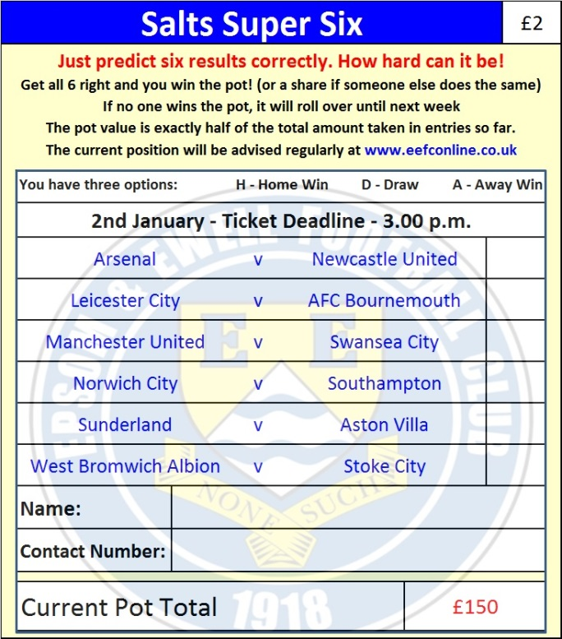

Good luck!

Combined Counties League – Premier Division
Saturday, 2nd January 2016 - Kick-off 3.00 p.m.
Epsom and Ewell  (Royal Blue & White hoops) | V |  | Redhill  (All Yellow)
Squad | NUMBERS |  | Squad
Michael Eacott |  |  | Jindrich Volkaty
Rhys North |  |  | Luke Jones
Alex McKay |  |  | Lea’van Sullivan
Craig Hastings |  |  | Alex Filipe
Dan Dean |  |  | Fiachra McArdle
Carl Downs |  |  | Abi Bolagi
Reisse Griffin |  |  | Jeffrey Addo-Dankwa
© Matt Farrell |  |  | Alex Rose
Kyle Hough |  |  | Chamal Fenelon
Tom Neale |  |  | Ricky Campbell
Matt Ferdinando |  |  | Luke Turner
James Taylor |  |  | Jordan Anderson
Beckett Oliver |  |  | Charlie Cook
Rob Hendry |  |  | Jeffrey Komoto
Matt Tanton |  |  | Simon Mensah
Savvas ‘Agi’ Panayiotou |  |  | Aaron Murphy
Adrian Jones |  |  | Marcus Green
Sam Currie |  |  | Josh Bonnett
Alex McGregor |  |  | Reece Brewster
Matt Smith |  |  | Andrew Dalhouse
Jamie Hatfield
Glyn Mandeville | MANAGER |  | Michael Maher
Matt Smith | ASSISTANT
Steve Eacott / Alex McKay / Jimmy Hendry | COACHES / PHYSIO |  | Megan Cornelius-Jones
REFEREE: R.Letheren (Chessington)
ASSISTANTS: not available at time of going to print
Today’s Match and Match Ball are sponsored by
one of our newer supporters, David Lawton

OUR NEXT VISITORS TO HIGH ROAD ARE:
Ashford Town (Mx)
Tuesday 12th January 2016 - Kick-off 7.30 p.m.
Combined Counties League Cup – Third Round

